INTERNAL REFERENCE GUIDE
Apache Superset 6.0
Capabilities and limitations for BI delivery
Scope: Apache Superset 6.0.0, focused on self-service BI and dashboard delivery
Analytical database: ClickHouse — the OLAP/serving database for analytical data
Audience: BI freshers, BI analysts, dashboard owners, data engineers and Superset administrators
Version: v1.6
Review date: 18 August 2026
Purpose: Set expectations before building, migrating or validating dashboards
Bottom line
In this scope, ClickHouse is the analytical/serving database; Superset is the query, exploration and visualization layer over modeled data. Superset does not replace a warehouse, ETL/orchestration or a full enterprise semantic layer.
Document version: v1.6 | Superset scope: 6.0.0 | Source basis: official Apache Superset documentation

1. Executive summary
Apache Superset 6.0 is an open-source web BI application; in the target stack for this guide, it connects to ClickHouse to create charts, dashboards and analysis workflows. Its value depends directly on the quality of the data model, query performance, caching, asynchronous execution and security design behind it.
The most accurate mental model is: Superset generates SQL, sends the SQL to the database, receives the result and presents it to users. It stores metadata for charts, dashboards and users, but it does not own the analytical data. Dashboard performance is therefore a property of the whole system, not only of the Superset UI.

Usage direction
Decision lens | Practical meaning
Strong fit | KPI dashboards, operational analytics, ad-hoc SQL and self-service exploration on a modeled warehouse/OLAP layer.
Fit with guardrails | Multi-table analysis, multi-tenant access, long-running queries and scheduled delivery - these need pre-modeling, RBAC/RLS and supporting infrastructure.
Do not use alone for | ETL/ELT, data-quality pipelines, orchestration, a data warehouse, full lineage/catalog or a database firewall.
Required prerequisites | Canonical datasets with clear grain, a metric catalog, correct temporal columns, testable access controls and agreed performance thresholds.
Source basis: [1], [2], [4], [9].

2. Scope and how to read this guide
- This guide describes Superset 6.0.0 using official Apache Superset documentation reviewed on 18 August 2026.
- A capability may require a feature flag, database driver, Redis/Celery/SMTP/headless browser configuration or specific database-engine support.
- The Looker migration discussion is an implementation lens for planning; confirm it with a pilot and acceptance tests on real data.
- This guide does not replace the installation guide, security hardening guide or production operations runbook.

3. Capability map
Area | What Superset can do | Conditions / notes
Data connectivity | Connect to SQL-speaking datastores/data engines through a Python DB-API driver and SQLAlchemy dialect. | Requires driver, URI, credentials, network path and dialect testing.
Data exploration | Explore is a no-code chart builder; SQL Lab is a SQL IDE for querying, joining and preparing data. | Users still need SQL, grain, filter and dialect literacy.
Datasets and metrics | Register physical/virtual datasets; create metrics, calculated columns and column metadata. | The semantic layer is thin; it does not solve data modeling or metric governance by itself.
Charts and dashboards | Support many charts, time series, tables, pivots, geospatial views, Markdown, annotations and native filters. | Chart controls, row limits, map resources and dashboard UX need standards.
Advanced analytics | Provide rolling mean, time comparison and resampling in the exploration workflow. | Not a full statistics, ML or notebook platform.
Security and access | Provide roles/RBAC, database/dataset permissions, dashboard RBAC, row-level security and OAuth/LDAP. | Combine with least privilege and database security; Superset is not a database firewall.
Alerts and reports | Send alerts on SQL conditions or scheduled reports through email/Slack. | Disabled by default; needs Celery beat/worker, SMTP/Slack and a headless browser.
Data and PDF export | Export chart/dashboard data or images/PDF and run scheduled reports when the feature, permissions and dependencies are enabled. | PDF is a separate layout output; it is not automatically the same as the dashboard viewport or a slide. Test page size, scale, labels and whitespace.
Bubble/scatter chart | Show X/Y relationships and encode a metric as bubble size, with groups separated by color or legend. | Points near the edge or at the same coordinates can be clipped/overlapped; test axis domain, bubble size, transparency and jitter.
Performance | Provide caching for filter/form/chart data and asynchronous queries through Celery. | Needs Redis/RabbitMQ, a results backend, monitoring and warehouse tuning.
API and extensibility | Provide a REST API, embedded SDK, custom visualizations/plugins, theming and import/export. | Requires engineering capability, version governance and compatibility testing.
File upload | Upload CSV/Excel into a database when the feature is enabled on the connection. | Controlled analysis support, not an ingestion pipeline.
Source basis: [1]-[10].

4. Architecture and operating model
In the target stack, ClickHouse is the analytical/serving database; the basic processing flow for a Superset chart or dashboard is:
- A user opens a chart or dashboard and selects filters or a time range.
- Superset builds SQL from the dataset, metrics, filters, chart configuration and security rules.
- ClickHouse executes the SQL, aggregation and filters; this is where most analytical processing happens.
- Superset receives the result set, applies cache when available and renders the chart or dashboard.
ClickHouse executes most analytical SQL. Supporting Superset components include a metadata database for charts, dashboards, users, connections and logs; a cache layer for state and results; and workers plus beat for asynchronous queries, thumbnails, alerts and reports. A PyPI installation creates only the core application, so supporting components must be configured separately when needed.
Important boundary
If the SQL, view or warehouse is slow, changing the chart type usually does not fix the root cause. Caching and asynchronous execution improve user experience and stability, but they do not replace good dataset design, partitioning, pre-aggregation and query tuning.
Source basis: [4], [5], [6].

5. Capability detail

5.1 Data connectivity
In this scope, Superset connects to ClickHouse as the analytical/serving database through a compatible DB-API driver and SQLAlchemy dialect. The same pattern can extend to other supported warehouse or OLAP engines.
Capability: Connect to common engines such as PostgreSQL, MySQL, ClickHouse, Trino, BigQuery, Snowflake and other supported engines.
Workflow: An administrator creates the database connection; a BI owner registers a table or view as a dataset; analysts use the dataset in Explore or SQL Lab.
Watch-out: The same chart can behave differently across dialects; test time grains, date functions, subqueries, LIMIT behavior and type casting.
Primary sources: [1], [2], [9].

5.2 Explore and SQL Lab
Superset offers two complementary workflows: Explore for visual configuration and SQL Lab for preparing, testing or reusing SQL.
Explore: Select a dataset, chart type, time column, group by, metric, filter and display options, then run the query.
SQL Lab: Write SQL with joins and CTEs, create virtual datasets and save queries for the Explore workflow.
Jinja templating: Use templates or macros for filters, time ranges, user context or metrics when the feature is enabled.
Risk: SQL Lab adds flexibility but also increases the need for SQL review, permission management and query-cost controls.
Primary sources: [2], [5], [9].

5.3 Datasets and semantic layer
Superset's semantic layer is thin: useful for sharing metrics and metadata across charts, but not a complete enterprise data model.
Metric: Store aggregation SQL such as SUM, COUNT or ratio formulas for reuse in Explore.
Calculated column: Store an expression for a column; this layer is not the place for aggregation functions.
Column metadata: Mark fields as temporal, filterable or dimensional and define formatting so Explore understands their role.
Recommendation: Document grain, numerator/denominator, filter scope, null handling, owner and business definition for each metric.
Primary sources: [2], [5].

5.4 Charts, dashboards and analysis
Superset supports charting from simple to multidimensional and combines charts into dashboards with filters, layout and explanatory content.
Visualizations: Tables, pivots, bars, lines/time series, big numbers, geospatial charts and other plugins.
Dashboards: Resize charts, publish dashboards, add Markdown, filters and annotations to provide context.
Advanced analytics: Use rolling mean, time comparison and resampling for trend and period analysis.
Limitation: Each visualization has its own controls, row limits and behavior; define chart standards and acceptance criteria by use case.
Primary sources: [1], [3].

5.5 Security, access and RLS
Superset uses Flask AppBuilder for authentication, user management, permissions and roles. Access can be organized by database, dataset, dashboard and row-level rules.
RBAC: Standard roles such as Admin, Alpha, Gamma, sql_lab and Public provide a starting point; create additional roles for access profiles.
Database/dataset access: Database access is broad; dataset access is more suitable for detailed access profiles.
RLS: Filters attached to a table and role are added to the WHERE clause; multiple rules are combined with AND.
Defense in depth: Superset provides SQL safeguards, but the official documentation emphasizes that database security and least privilege remain the responsibility of the DBA/security team.
Primary sources: [2], [8].

5.6 Alerts, reports and sharing
Superset can send alerts when a SQL condition is met and send chart/dashboard reports on a schedule. This is an operational capability, not only a UI setting.
Alert: Trigger delivery when a SQL condition reaches a threshold.
Report: Capture a chart or dashboard and send it on a schedule.
Channels: Email or Slack, depending on configuration.
Dependencies: Feature flag, Celery beat, SMTP or Slack token, worker and a headless browser.
Primary sources: [4], [7].

5.7 Caching and asynchronous queries
Caching reduces repeated queries; asynchronous execution moves long queries out of the synchronous web request. Together they help Superset remain stable with heavier dashboards and more users.
Cache: Support filter state, Explore form data, metadata and charting-data caches; Redis is commonly recommended.
Async: Long queries can run through Celery workers, a broker and a results backend.
Operations: Keep web-server and worker configuration aligned; monitor queues, TTL, freshness and serialization errors.
Expectation: Asynchronous execution does not make inefficient SQL fast; it changes how work is waited for and distributed.
Primary sources: [4], [5], [6], [9].

5.8 API, embedding and extensibility
Superset provides a public REST API and can be extended through custom visualizations, extensions, themes, the embedded SDK and import/export mechanisms.
API: Automate selected administration and content-delivery workflows through the official API.
Embedding: Integrate dashboards into an application through supported embedding mechanisms.
Custom visualizations: Build a chart plugin when the built-in visualization set does not meet the requirement.
Governance: Give custom code, feature flags and themes an owner, pinned versions, a release checklist and regression tests.
Primary sources: [1], [10].

5.9 PDF export and report presentation
Treat PDF export as a separate output format, not as an automatic copy of the browser dashboard viewport. Test the actual PDF before using it for business reporting or presentation.
Observed behavior: The browser dashboard uses the viewport effectively, but the exported Meko PDF places a small chart near the top of an A4 portrait page; most of the page is empty and labels are harder to read.
Deployment cause: Page size, orientation, capture area, scale and headless/report configuration can differ from the dashboard viewport; the chart may not reflow to the PDF page.
Acceptance: Check page size/orientation, title, chart size, legend, labels, clipping, whitespace, multi-page flow and readability at 100% zoom.
Recommendation: Use landscape for multi-chart dashboards, reduce the number of charts per page, standardize titles/labels and use a screenshot/report or separate layout tool when native PDF output is not presentation-ready.
Product basis: [7], [21]; observed evidence: the dashboard screenshot and Meko PDF supplied by the user.

5.10 Bubble charts: clipping and overlap
Bubble charts need a separate check for axis domains, bubble size and point distinguishability. A successful query does not mean that every bubble is rendered correctly inside the plot area.
Observed behavior: In the Consumption_buble_chart_ver2 screenshot, the groups sit at or very close to x = 1; the large FEMALE bubble touches/crosses the right plot boundary, while other bubbles can be hidden or difficult to distinguish.
Likely causes: X may have only one distinct value or be normalized/clamped to 1; the auto domain ends at 1 while the bubble radius extends beyond it. Points sharing X/Y or an oversized bubble radius also create overlap.
Acceptance: No bubble is clipped by the plot boundary; groups with the same coordinates remain distinguishable through color, opacity, tooltip or jitter; axis range, labels and size scale reflect the source data.
Fix direction: Check distinct/min/max X/Y values in SQL, add padding or set the axis domain, cap the maximum bubble size, use transparency/jitter/small multiples or switch chart type when the data is not suitable for a bubble chart.
Explore workflow basis: [3]; observed evidence: the Consumption_buble_chart_ver2 screenshot supplied by the user.

6. Limitations and risk controls
Read this before committing to the design
The limitations below are not reasons to reject Superset. They are boundaries that should be converted into data standards, architecture decisions and acceptance tests.
Limitation | Why it matters | Risk control
Not storage/ETL | Superset has no analytical storage layer; the existing database stores and processes the data. | Use a warehouse/lakehouse/ETL/dbt layer to publish modeled canonical datasets.
Joins in Explore | The Explore/Visualization UI works with one table or view; multi-table joins belong in SQL Lab or a pre-modeled view/dataset. | Define grain and create canonical views/datasets; do not let every analyst rebuild joins.
Thin semantic layer | Metrics and calculated columns help, but do not replace relationships, lineage, reusable models or full governance. | Maintain a metric catalog, data contract, owner, review process and metric tests.
Performance depends on the warehouse | Superset is a thin layer; the source database executes most SQL. Poor SQL or views cause slowness and timeouts. | Benchmark SQL, use partitions/pre-aggregation, row limits, cache, async and p50/p95 monitoring.
Async/cache need infrastructure | Redis/RabbitMQ, a results backend, workers/beat and TTL add operational complexity; cached results can become stale. | Define freshness/TTL, monitor queues and cache, and keep a stale-result runbook.
Alerts/reports are not enabled by default | Feature flags, a scheduler, SMTP/Slack and a headless browser are required dependencies. | Treat this as a separately owned capability with end-to-end tests.
Security is defense in depth | Built-in SQL safeguards do not guarantee protection against every database threat; incorrect RLS can over-restrict or over-expose data. | Use least privilege at the DB, a role matrix, persona-based RLS tests, audit logs and secret/CSP hardening.
Metadata and recovery | SQLite is not suitable for production; the UI currently has no trash bin for recovering deleted assets. | Use managed Postgres/MySQL, scheduled backups, dashboard exports and restore tests.
Dialect/driver differences | Time grains, subqueries, functions, types and SQL portability vary by engine and driver. | Pin versions, test connectors, maintain a compatibility checklist and provide fallback SQL.
Uploads/custom maps | CSV/Excel upload is enabled per connection; custom visualizations and maps may need packages, API keys or external resources. | Govern uploads as data access; review plugins and control external resources/CSP.
Bubble/scatter clipping or overlap | When groups share X/Y or X is exactly at the maximum domain, a large bubble can be clipped at the edge or hide other points; the chart may still run without an error. | Check distinct/min/max values, add domain padding, cap bubble size, use opacity/jitter/tooltips and test with multi-group data.
Dataset import can fail | After a file is selected, Import dataset may return an error such as 'Could not find a valid command to import file'; behavior depends on connection settings, a valid import command and the file's format/export compatibility. | Do not use UI upload as the primary ingestion path for production datasets. Re-export the file; check delimiter, encoding, header and schema; verify upload configuration on the connection; or load through a pipeline/SQL/database and register the resulting table/view in Superset.
Source basis: [2], [4]-[9].

6.1 Additional points from the reference checklist
The list below is added from the reference image supplied by the user. These are planning boundaries to validate on the target deployment; items 11 and 23 are available capabilities, but their coverage or enforcement still needs testing. Numbering restarts at 1 for each group for easier review.

A. Data Modeling & Semantic Layer
- The semantic layer is narrow; use pre-modeling, a metric catalog and data contracts for shared definitions.
- Ad-hoc calculations across dimensions are limited; move complex logic to SQL Lab, virtual datasets or upstream modeling.
- There is no native relational model equivalent to Power BI/LookML; relationships, joins and reusable models must be designed in the data layer.

B. Architecture, Performance & Operations
- Superset has no separate analytical storage/in-memory engine; it depends on the database/warehouse/OLAP layer behind it.
- Each chart commonly issues its own query; multi-chart dashboards need caching, asynchronous execution, pre-aggregation and a query budget.
- Native ALM and version control are weak; use export/import, Git or the API, named owners and a release checklist.
- Audit trail is not a first-class component; combine application logs, database audit and an evidence-retention process.
- Alerts and Reports require several operating components, including a scheduler, workers, SMTP/Slack, a headless browser and monitoring.
- Documentation and support depth vary across connectors, plugins and use cases; pin versions and test the real deployment.

C. Governance, Security & Advanced Interaction
- RLS exists, but dynamic entitlement is not a first-class experience; complex entitlement should also be controlled in the database or an access service.
- Cross-filtering and drill are native in some workflows, but coverage and behavior depend on the chart, dataset, dimensions and configuration.
- What-if parameters are not a first-class feature; they usually require metric modes, SQL/Jinja, parameters or separate charts/datasets.
- Personal bookmarks/My View are limited compared with a full personalization experience; define how saved charts, dashboards and filter state are managed.
- AI/NLQ integration is not a standard capability for every deployment; assess feature flags, security, answer quality and governance separately.

D. Layout, Presentation & Distribution
- Dashboards use a grid rather than a free-form canvas; pixel-level alignment and overlay must stay within grid constraints.
- CSS cannot deeply and reliably control every ECharts detail; prefer themes, chart controls and plugins over per-chart CSS hacks.
- A dedicated mobile layout remains limited; test breakpoints, filter width, tables and labels on small screens.
- Export/print is harder to control than the browser viewport; page size, orientation, scale, labels and whitespace need their own acceptance test.
- The canvas does not provide free-form overlay composition inside the plot like a graphic design tool; complex overlays may need a custom visualization or external tool.

E. Chart Creation & Visual Design
- Explore is more form-driven than direct manipulation; users choose controls instead of directly dragging and editing every chart element.
- Changing chart type can lose or alter mappings; recheck dimensions, metrics, series, labels and filters after switching.
- Conditional formatting outside tables is limited; complex requirements may need SQL flags, another chart type or a custom visualization.
- Theming was substantially improved in Superset 6.0, but a theme does not automatically enforce every chart standard, metric format or layout rule.
- Format controls are not consistent across plugins; do not assume every chart exposes the same label, number-format, axis-bound or tooltip controls.
- Small multiples are not a common mechanism across all charts; use separate charts, filters or a custom plugin when needed.
- Annotations are supported, but the workflow has several steps; define an owner, naming, source and review process.
- Icons/images in KPI charts remain limited; when an icon is mandatory, validate the chart type, Markdown/KPI card or a custom frontend.
Reference checklist supplied by the user; validate each item against the target Superset deployment.
Observed UI limitation
SQL Lab returns/displays rows according to the selected Limit; in the observed environment, the dropdown exposes values up to 100K. The result panel may show '1K rows' but does not provide a Looker-style total such as '1–50 of 4,179,151'. When a total is needed, run COUNT(*) or COUNT(DISTINCT ...) with the same filters or publish a Total rows KPI; use Limit for preview and paginate/keyset or export through a pipeline for large detail. Do not use unlimited retrieval for raw production tables because of memory pressure, timeouts and warehouse/ClickHouse load.
UI row-limit behavior: [19], [20].

7. Feasibility assessment against the two redesign plans
The two decks define a concrete target experience: L1/L2 dashboards, KPI trends, metric modes, cross-filters, maps, heatmaps, deciles, alerts, exports and several enterprise use cases. The conclusion is that Superset 6.0 + ClickHouse is a good serving and interaction layer for most of the scope, but application-like cross-page behavior should be proven in a spike before it is promised.
Feasibility conclusion
An MVP for Executive Summary, Merchant Insight L1/L2, demographics, geography, visit timing and decile analysis is feasible with pre-modeled datasets. Do not promise that a click on every KPI will automatically change the metric, navigate to another view and preserve all context exactly like Looker Studio; that is a risk area to spike.

Feasibility matrix by capability
Deck requirement | Fit | Superset implementation path | Limitation / condition
ClickHouse serving + Superset interaction | High | Connect ClickHouse, publish aggregate/canonical datasets and build charts and dashboards in Superset. | Install the clickhouse-connect driver, test the dialect and benchmark queries on the real stack.
L1/L2 navigation and persistent global filters | High within one dashboard; conditional across dashboards | Use dashboard layout, native filters, tabs/sections and links/navigation. | Preserving filter state across separate dashboards needs URL/state design or a single-dashboard composition; do not assume it is native.
KPI cards + daily / weekly / monthly + MoM / YoY | High with conditions | Use a correct time column, aggregate datasets and a metric contract for current/comparison periods. | Test business-calendar semantics, timezone and date boundaries; do not average daily ratios.
Count / Share / Growth / Index switch | Medium to high | Predefine a metric set or use SQL/Jinja/parameters to select the mode; keep one semantic contract. | One control that changes every chart, KPI, mover and alert is not a default behavior across arbitrary datasets.
Cross-filter from age, gender, province, merchant and brand | High with conditions | Use cross-filters/native filters on charts with compatible dimensions and shared fields. | Not every chart or scalar KPI creates a filter; prove scope across multiple datasets and chart types.
Map: member size + growth colour; province drill | Medium | Use Country Map/Deck.gl, province codes or coordinates, map tiles and a companion ranking table. | Country Map is primarily choropleth; size + growth colour + drill/cross-filter may require another chart, two charts or a custom visualization.
Alert cards: last 24h + cause + action | Medium | Use SQL alerts/reports for thresholds and an alert dataset to render an in-dashboard list. | Superset does not infer root cause/action text; upstream or SQL logic, scheduling, ownership and workflow are required.
Hover metric definition: formula / source / update time | Medium | Register metric/column metadata and use chart descriptions plus a display convention. | A consistent hover contract across every KPI, chart and table needs templates or customization; it is not automatic.
CSV/image export and export to slides | High for CSV/image; lower for slides | Use chart/table export and report screenshots; CSV/XLSX are suitable for data. | One-click copy directly into PowerPoint is not a uniform native output; use screenshot/report workflows or an external tool.
L3 row-level/member/transaction detail | Medium to high | Curate a detail dataset, use a table/drill-to-detail view, row limits, RLS and audit. | Do not expose raw tables; validate column selection, export, volume and PII handling.
Shared CSS, fixed colors/chart types and reusable datasets | High for themes; medium for enforcement | Use Superset themes, palettes, naming/chart standards and a dataset catalog. | Themes help consistency but do not force every analyst to use the approved chart type or metric; governance and review are needed.
Weekly refresh aligned to the meeting cycle | High | Refresh the upstream dataset; query on demand or use cache according to freshness. | Superset does not replace ingestion/orchestration; define freshness, cache TTL and update timestamps.
Deck basis: user-provided Redesign Plan of WAON POINT Dashboard v0.1 and Merchant Analysis Dashboard Redesign Plan v0.4(2). Product references: [1], [4], [13]-[18].

Fit matrix by dashboard/use case in the decks
Dashboard / view in the deck | Fit | What must be ready | Primary caveat
WAON Executive Summary | High | KPI dataset, target/actual and metric contract. | Keep L1 focused; do not turn it into the entire drill-down surface.
Merchant Insight L1 + L2 demographics | High with conditions | agg_merchant_daily/agg_segment_daily, member-period grain, age/gender/new-existing. | KPI click context and filter carry-over across L1/L2 need a spike.
L2 Geography / province catchment | Medium to high | Province mapping, ISO/province code, coordinates/GeoJSON, store master and unknown mapping. | Map size + growth colour + drill should not be promised from one Country Map chart alone.
L2 Visit Timing | High | Transaction timestamp, timezone, hour/weekday/daypart and time aggregates. | Control timezone, missing timestamps and cell volume when filters become granular.
L2 Decile / RFM | High with conditions | Precomputed ntile/RFM by period and member grain; sales/share/growth metrics. | Superset displays and filters the result; it is not the segmentation-model training layer.
Mall Insight / target vs actual | High with conditions | Target table, store-week/month grain, business calendar and gap metric. | Target alignment and late-arriving data must be tested before the meeting cycle.
Point & Voucher / Promotion Effectiveness | Medium to high | Campaign, issuance, redemption, cost and attribution model. | ROI/attribution is not created by the chart; it needs a data model and contribution definition.
Cross-Merchant Flow | Medium | Member-store edge table, visit sequence, graph/flow metric and volume controls. | A flow chart may need a plugin/custom visualization; large graphs are hard to read and can be expensive.
Fraud Detection | Medium | Flag/rule table, suspicious-transaction detail, RLS and an alert owner. | Superset is the observation layer; it is not case management, the scoring engine or the investigation workflow.
AEON Finance Potential | Medium | Upstream interest score/profile, privacy classification and role/RLS. | Superset displays the score; it does not create the propensity model and sensitive data needs extra controls.

Mandatory spikes before build
Spike before build | Why it is high risk | Pass condition
KPI click-to-context across L1/L2 | One click may need to change metric and filter state across several charts or dashboards. | Each KPI updates trend, movers and alerts correctly; return navigation preserves filters and does not create wasteful queries.
Global metric mode | Count/share/growth/index have different semantics, especially for ratios and comparison periods. | One control produces correct results for KPI, trend, table and export.
Province map | One visual is expected to combine geographic shape, bubble size, growth colour, tooltip and cross-filter. | Vietnam province mapping, unknown rate, performance and click filtering meet acceptance.
Alert panel | A SQL threshold is not the same as an explanatory cause and action. | The alert dataset updates on schedule, includes owner/status/source, sends notification and de-duplicates alerts.
Detail + export + access | Row-level detail is both large and PII-sensitive; drill views have their own limits. | Personas see only allowed rows/columns; CSV respects row policy; response time meets the threshold.
Dashboard performance | Six KPIs plus trend, movers, alerts, four L2 views and persistent filters create many queries. | Measure p50/p95, concurrency, cache hit, async fallback and ClickHouse resource cost.
RLS/cache/alerts by persona | A dashboard may render differently per user; wrong cache or executor settings can leak data. | Negative-access tests, cache isolation, alert executor and audit evidence all pass.
The fit ratings are implementation recommendations based on the two decks and official Superset capabilities; they are not product guarantees.

8. Migration lens when moving from Looker
When moving from Looker to Superset, the hardest work is usually not redrawing charts; it is translating the model, metrics and governance. The table below is a lens for breaking down work and designing acceptance tests.
Topic | Common change in Superset | Guardrail to define
Data model | LookML model/Explore concepts need to map to Superset database connections, datasets/views and metrics. | Inventory models, datasets, grain, joins and owners before building.
Joins | Explore is not a free-form multi-table join surface; join logic usually moves to SQL Lab, views or canonical datasets. | Pre-model joins; test duplicate rows and fan-out.
Metrics | Measures/dimensions need to be re-expressed as dataset metrics, calculated columns or source SQL; do not copy only tile-level formulas. | Metric catalog with formula, grain, filter scope, numerator, denominator and owner.
Filters/time | Native filters, dashboard filters, URL parameters and Jinja can cover many cases, but semantics must be verified. | Test default, no filter, single/multi-select, timezone and date boundaries.
Performance | UX depends on the warehouse, query shape, cache and async behavior; timeout thresholds must be re-measured on the new stack. | Benchmark p50/p95, query cost, freshness and async fallback.
Security | Database/dataset permissions, dashboard RBAC and RLS must be redesigned by persona and data domain. | Role matrix, RLS tests and negative-access tests.
Release | Import/export, API, custom themes and alert/report infrastructure become part of the release checklist. | Owner, versioning, backup, rollback and post-release validation.
Comparison lens informed by [1], [2], [9], [11], [12].

9. Minimum standard before building a dashboard
Do not start by cloning every tile from the old dashboard. Freeze the following conditions first, especially for shared KPI dashboards or L2 demographics work.
- Define the canonical dataset: business grain, primary key, duplicate rule, temporal column, timezone and data freshness.
- Define the metric contract: formula, filter scope, numerator/denominator, null handling, currency/unit, owner and example value.
- Define column metadata: temporal, filterable, dimensional, format, label and description.
- Run the source SQL independently and in Superset; compare row counts, aggregates, date boundaries and sample records.
- Define performance acceptance: set an interactive threshold; use async for long queries; define row limits and refresh policy.
- Define security acceptance: personas, database/dataset permission, RLS, negative tests and cache-key behavior.
- Define chart/dashboard standards: naming, title, subtitle, filter layout, color, tooltip, empty state, download and validation status.
- Keep a mapping to the legacy Looker dashboard and record every approved difference.
Recommended project rule
Freeze the data grain and metric definitions before optimizing the dashboard layout. A fast dashboard with an ambiguous metric is still an incorrect dashboard.

10. Decision matrix by use case
Use case | Fit | Required conditions | Decision
KPI/operational dashboard | High | Modeled dataset, stable query and metric contract. | Use Superset as the primary BI layer.
SQL self-service / ad-hoc | High | SQL literacy, permissions and query governance. | Use Explore + SQL Lab with controls.
Large warehouse/OLAP | High with conditions | Tuned warehouse; cache/async when needed. | Benchmark before scaling users.
Multi-table analysis | Medium | Pre-modeled joins or controlled virtual datasets. | Do not leave joins to each chart.
ETL/data quality/orchestration | Low | Requires dedicated external systems. | Do not use Superset as the pipeline.
Enterprise semantic model | Medium | Additional metric catalog and governance. | Use Superset with a data modeling layer.
Scheduled reporting | Medium to high | Celery, headless browser, SMTP/Slack and monitoring. | Deploy as a separately operated capability.
This matrix is an implementation recommendation, not an Apache product guarantee.

11. Glossary
Term | Short definition
Dataset | A table or view registered for use in Explore or SQL Lab.
Physical dataset | A dataset that points directly to an existing table or view.
Virtual dataset | A dataset created from a SQL query, usually for analytical preparation.
Metric | An aggregation expression or formula reused by charts.
Calculated column | An expression applied to a column, not the place for aggregation.
Explore | No-code interface for selecting chart, dimension, metric, time and filter.
SQL Lab | SQL IDE for queries, joins, CTEs, validation and virtual datasets.
RLS | Row-level security; a role/table filter added to generated SQL.
Metadata database | Database storing chart, dashboard, user, connection and log definitions.
Cache / Celery | Cache stores state/results; Celery worker/beat runs async, report, alert and thumbnail tasks.

12. UI evidence and database context
The screenshots below were provided by the user and are included to document the observed difference between Looker and Superset in the current ClickHouse scope. They illustrate observed UI behavior, not a product guarantee for every Superset deployment.
Database used in this scope
ClickHouse is the analytical/serving database for this scope. Superset generates SQL, applies filters/RLS, receives the result set and renders the UI; the metadata database, cache and workers are separate operating components. Added from the Meko file: the A4 portrait PDF places a small chart near the top, leaves large unused whitespace and makes labels harder to read than the browser viewport. For the bubble chart, the new screenshot shows groups concentrated at x = 1 and the FEMALE bubble clipped at the right edge.
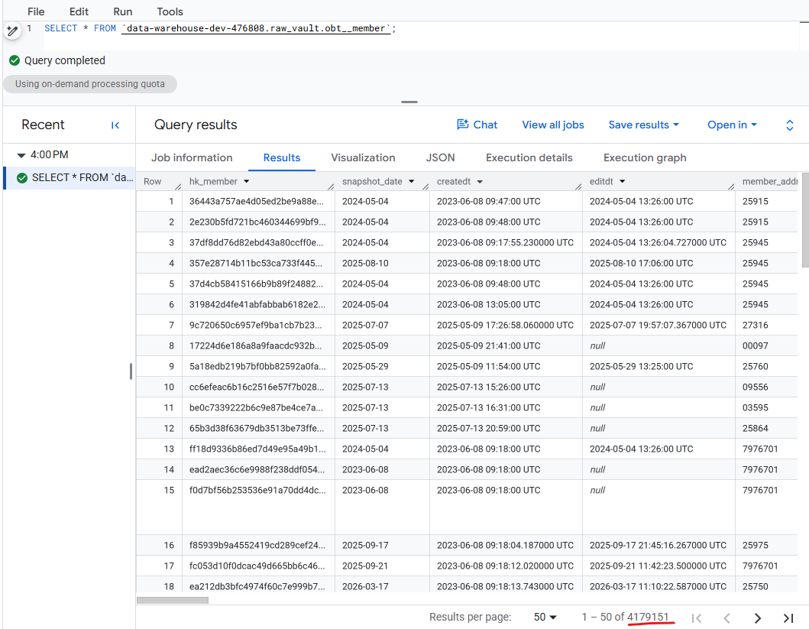
Figure 1 — Looker shows the current row range and total matched records: 1–50 of 4,179,151.

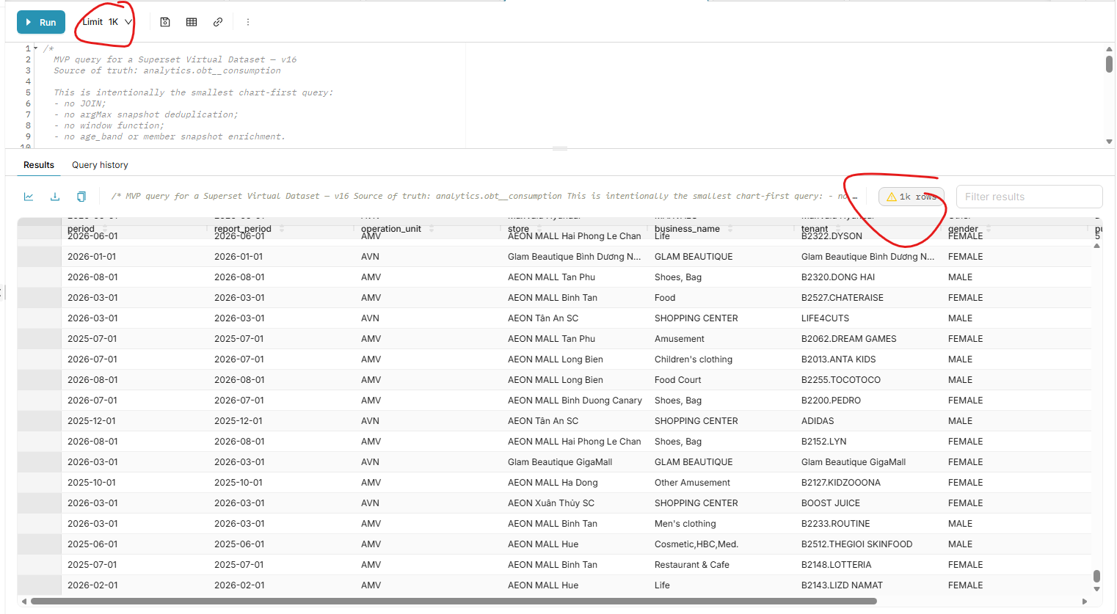
Figure 2 — Superset SQL Lab shows Limit 1K and the result label '1K rows'.

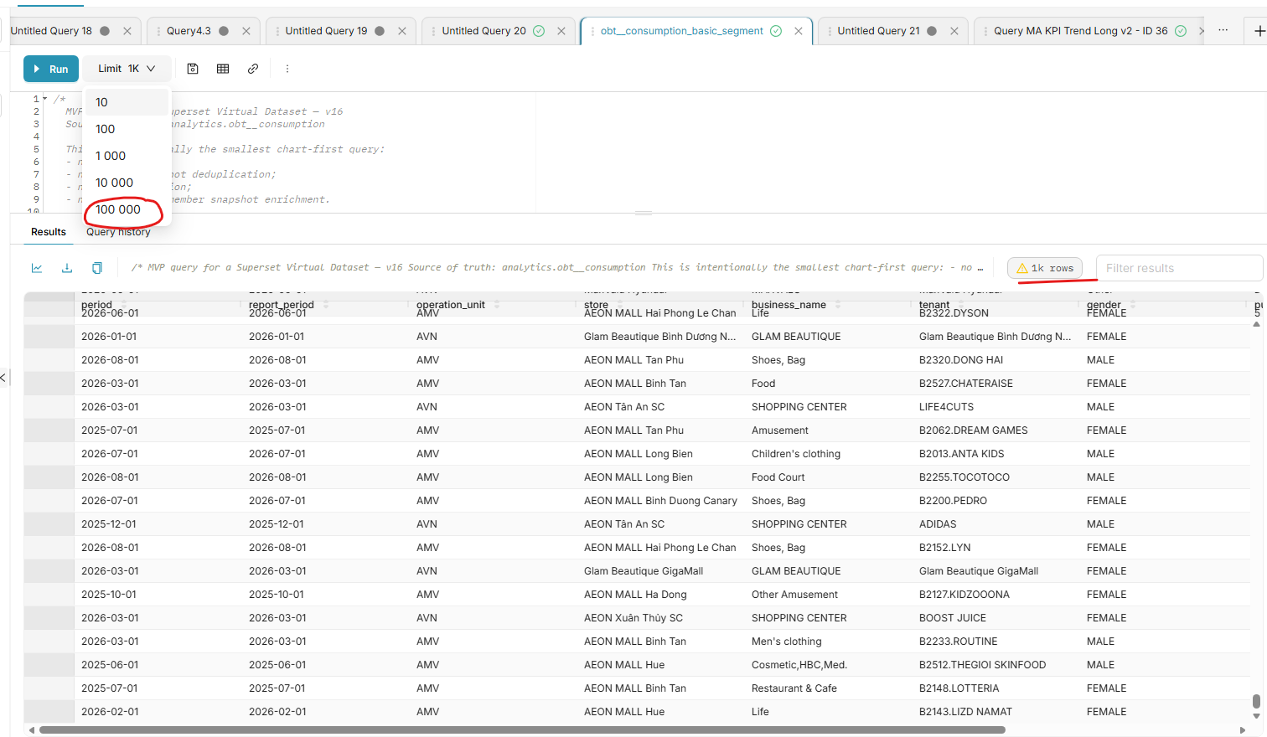
Figure 3 — Superset's Limit dropdown exposes a maximum of 100,000 in the observed UI.

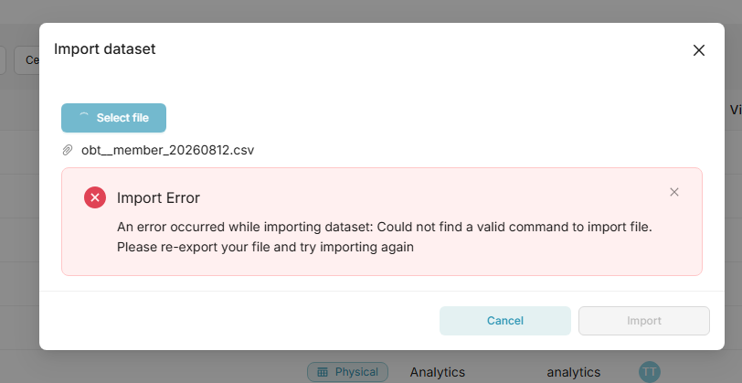
Figure 4 — Dataset import can fail with: 'Could not find a valid command to import file'.

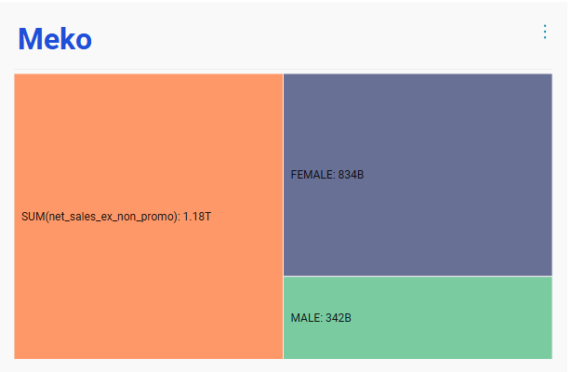
Figure 5 — Meko dashboard in the browser before export; the chart uses the viewport effectively and labels are easier to read.


Figure 6 — First page of the exported Meko PDF; A4 portrait leaves large whitespace, shrinks the chart and reduces label readability.

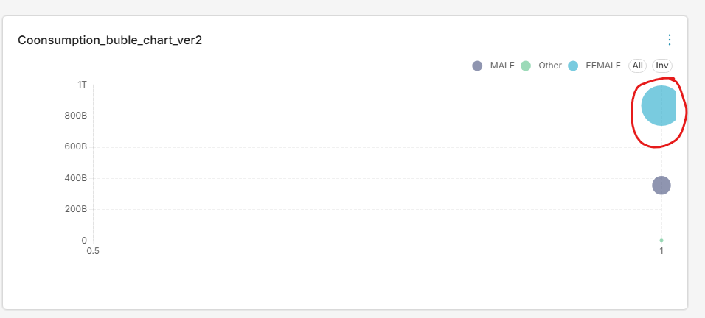
Figure 7 — Consumption_buble_chart_ver2; the FEMALE bubble at x = 1 touches/crosses the right edge, indicating clipping/overlap to validate.

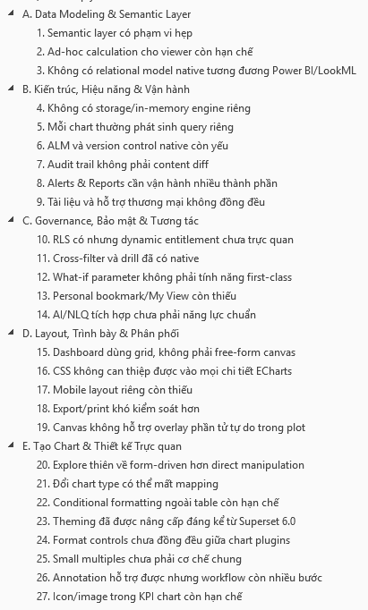
Figure 8 — Reference checklist supplied by the user; adds boundaries for the semantic layer, operations, governance, layout and chart design.
Screenshots provided by the user; analytical database in scope: ClickHouse.

13. References
The links below are the official sources used to check the scope of Superset 6.0.0 capabilities and limitations. The Looker comparison is a migration lens for planning, not a feature-parity statement.
[1] Apache Superset 6.0.0 - Introduction and Why Superset?
[2] Apache Superset 6.0.0 - Creating Your First Dashboard
[3] Apache Superset 6.0.0 - Exploring Data in Superset
[4] Apache Superset 6.0.0 - Architecture
[5] Apache Superset 6.0.0 - Caching
[6] Apache Superset 6.0.0 - Async Queries via Celery
[7] Apache Superset 6.0.0 - Alerts and Reports
[8] Apache Superset 6.0.0 - Security Configurations
[9] Apache Superset 6.0.0 - FAQ
[10] Apache Superset 6.0.0 - Change Log
[11] Google Cloud Looker - Introduction to LookML
[12] Google Cloud Looker - Working with joins in LookML
[13] Apache Superset 6.0.0 - Connecting to Databases
[14] Apache Superset 6.0.0 - Country Map Tools
[15] Apache Superset 6.0.0 - Map Tiles
[16] Apache Superset 6.0.0 - Theming
[17] Apache Superset - Product overview
[18] Apache Superset GitHub - SIP-160 Drill-to-Detail proposal
[19] Apache Superset GitHub - SQL Lab display row-limit logic
[20] Apache Superset GitHub issue #12509 - SQL Lab query max limit dropdown
[21] Apache Superset 6.0.0 - Granular Export Controls

